NOTICE OF TEMPORARY
USE PERMIT APPLICATION

Notice is hereby given that the Director of Community Development will consider the issuance of a Temporary Commercial Use Permit as follows:

TEMPORARY USE PERMIT NO. TUP19
Permit
A Temporary Use Permit application has been received from KEITH BROWN ASSOCIATES LTD., on behalf of 506675 BC LTD. (Mr. Tim Sangha) to permit a pet day care use within the existing building located at 1680 Northfield Road. The subject property is zoned Neighbourhood Centre (CC2), which does not permit the pet day care use, and is within the Light Industrial designation in the City of Nanaimo Official Community Plan (OCP). The permit if approved will expire on 2017-APR-10.
Location
The subject property is located at 1680 Northfield Road and is legally described as LOT B, SECTION 18, RANGE 8, MOUNTAIN DISTRICT, PLAN VIP56111, and is identified on Map ‘A’.

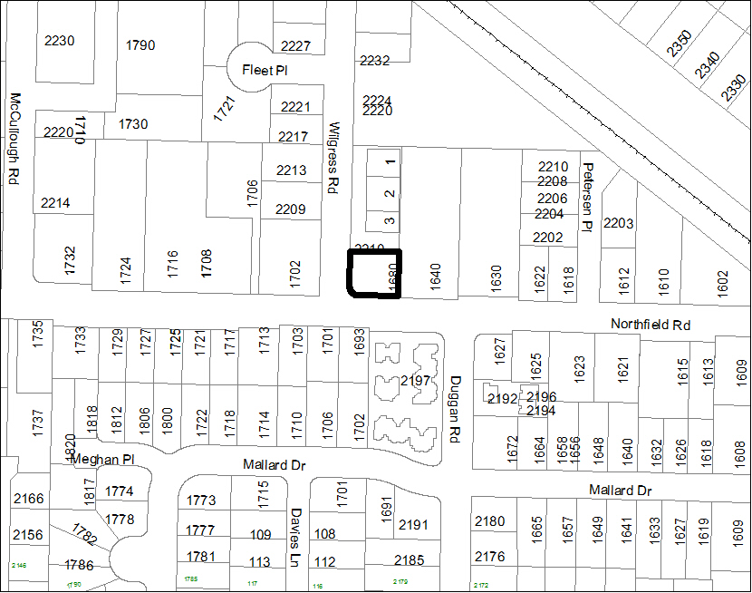
Map A

Subject Property:
1680 Northfield Road North

Opportunity for Public Input
The Temporary Use Permit application is available for viewing at the Service and Resource Centre, 411 Dunsmuir Street, Nanaimo, BC, during normal business hours, Monday to Friday, excluding weekends and statutory holidays, from 2014-MAR-31 to 2014-APR-10, inclusive. If you would like more information regarding this application you may contact Dave Stewart, Planner at
250-755-4429.
Northfield Road

On 2014-APR-10, the Director of Community Development will review all submissions and issues affecting the application and consider the issuance of this permit.

Comments regarding this application will be received by Planning and Design Section at
250-755-4460. Written submissions should be sent to the attention of the Director of Community Development, City of Nanaimo, 455 Wallace Street, Nanaimo, BC, V9R 5J6.

This notification is published in accordance with Section 921 of the Local Government Act.

Prospero: TUP19

