CITY OF NANAIMO

BYLAW NO. 6500.038

A BYLAW TO AMEND THE CITY OF NANAIMO
“OFFICIAL COMMUNITY PLAN BYLAW 2008 NO. 6500”

WHEREAS the Council of the City of Nanaimo wishes to amend City of Nanaimo “OFFICIAL COMMUNITY PLAN BYLAW 2008 NO. 6500”;

THEREFORE, BE IT RESOLVED that the Municipal Council of the City of Nanaimo, in open meeting assembled, ENACTS AS FOLLOWS:

- This Bylaw may be cited as the “OFFICIAL COMMUNITY PLAN AMENDMENT BYLAW 2018 NO. 6500.038”.

2. The City of Nanaimo “OFFICIAL COMMUNITY PLAN BYLAW 2008 NO. 6500” is hereby amended as set out in Schedule A to this Bylaw.

PASSED FIRST READING: 2018-MAY-07
PASSED SECOND READING: 2018-MAY-07
RESCIND SECOND READING: 2018-MAY-28
PASSED SECOND READING AMENDED: 2018-MAY-28
PUBLIC HEARING HELD: 2018-JUN-07
PASSED THIRD READING: 2018-JUN-07
ADOPTED: 2018-JAN-21

L. E. KROG
MAYOR
S. SNELGROVE
DEPUTY CORPORATE OFFICER

File: OCP00087
40 Maki Road

SCHEDULE A

- Map 1 (Future Land Use Plan) of the “OFFICIAL COMMUNITY PLAN BYLAW 2008 NO.6500” is amended as follows:

a) Re-designate the subject area known as LOT 1, BLOCK 1, SECTION 2, NANAIMO DISTRICT, PLAN 630, EXCEPT PARTS IN PLAN 1099R AND 35898, SEE MANUFACTURED HOME ASSESSMENT ON 16197.001 (40 Maki Road) from ‘Neighbourhood’ to ‘Light Industrial.’

- Schedule A (Futre Land Use and Mobility) of “OFFICIAL COMMUNITY PLAN BYLAW 2008 NO. 6500 SCHEDULE C” is amended as follows:

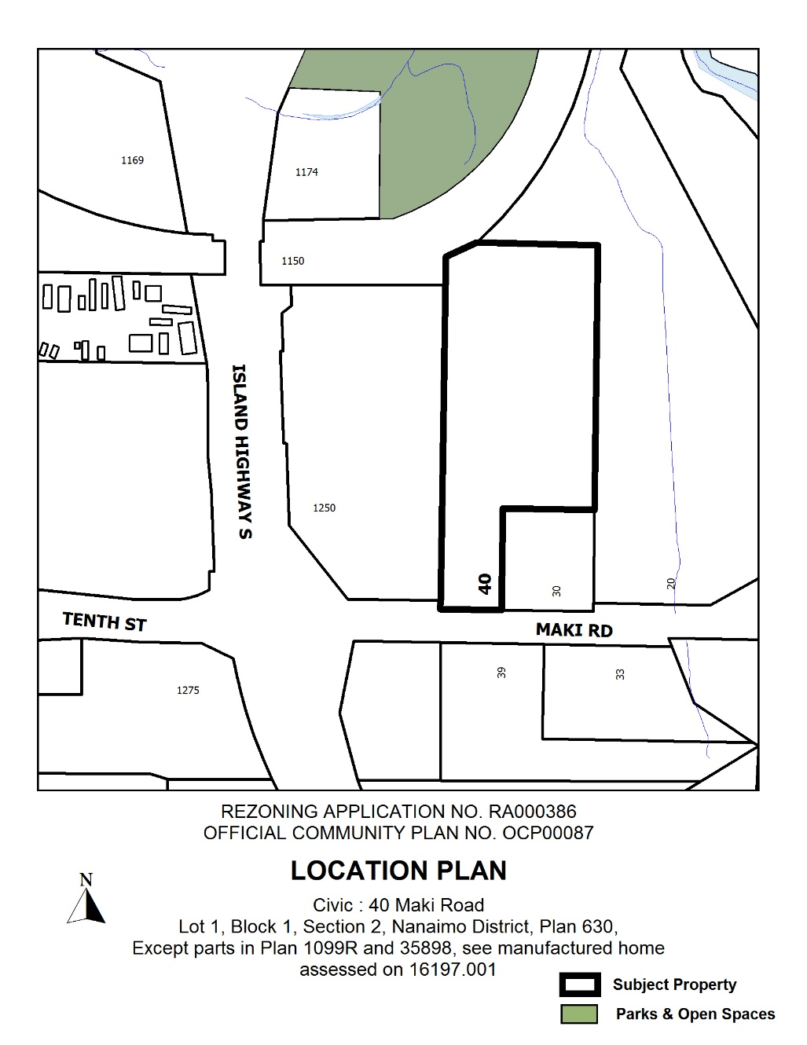
- Re-designate the subject area known as LOT 1, BLOCK 1, SECTION 2, NANAIMO DISTRICT, PLAN 630, EXCEPT PARTS IN PLAN 1099R AND 35898, SEE MANUFACTURED HOME ASSESSMENT ON 16197.001 (40 Maki Road) from ‘Low-Medium Density Residential’ to ‘Service Industrial Enterprise Area.’

