Construction and Demolition Site

FIRE SAFETY PLAN

FOR

Project

Name

Address

Produced By: Name
Address
Telephone: (250) 000-0000

**INSTRUCTIONS

All demolition and construction sites require a fire safety plan in conformance with Sections 2.8 and 5.6 of the BC Fire Code. The fire safety plan shall be forwarded (as a PDF doc) to the Fire and Loss Prevention Division at Nanaimo Fire Rescue FLPD@nanaimo.ca for review prior to the commencement of construction or demolition operations. The fire safety plan must be reviewed and updated as construction/demolition progresses.

Enter the information for your job site into the green high-lighted areas. Once the information is entered remove the green text highlighter.

Any parts of this plan which do not apply may be marked NA (not applicable) or removed.

**Remove these instructions from the final draft of the plan

CONTACT NAMES AND PHONE NUMBERS

GENERAL CONTRACTOR: Company Name
TELEPHONE: (250)-000-0000

PROJECT MANAGER: Name
TELEPHONE: (250)-000-0000
EMERGENCY: (250)-000-0000

SITE SUPERVISOR: Name
TELEPHONE: (250)-000-0000
EMERGENCY: (250)-000-0000

PROPERTY OWNER / REPRESENTATIVE: Name
TELEPHONE: (250)-000-0000
EMERGENCY: (250)-000-0000

EMERGENCY AND CRITICAL PHONE NUMBERS

Fire Department 911
Police Department 911
Ambulance 911

Nanaimo Fire Department Non Emergency (250) 753-7311
Nanaimo RCMP Non-Emergency (250) 754-2345

Fire Alarm Service Name of Company ……………… (250) 000-0000

Sprinkler Service Name of Company ………………(250) 000-0000

Fire Alarm Monitoring Name of Company …………....…(250) 000-0000

1. PROJECT SUMMARY
Describe the proposed project including: nature of work (demolition, alteration and/or construction), changes occurring to an existing building, number of project phases, project timeline, hours of work, number of workers, etc.
For projects involving multiple phases, describe each phase of the project.
Where part of the building continues to be occupied, resubmit an updated fire safety plan for approval prior to the start of each phase.

A copy of this fire safety plan will be kept on-site at the site office.

2. BUILDING DESCRIPTION

No. of stories above grade: 3
No. of stories below grade: 1
No. of suites: 28 Residential
1 Commercial Business

Year of Construction: 2009 / 2010
Main Construction Materials: Wood Frame
Exterior Finish: Hardy-board and wood trim
Roof Construction: Shingles supported by wood
sheathing & wood joists
Interior Construction and Finish: Gypsum wall board on top of metal &
wood studs covered by various wall
coverings and metal trim

3. FIRE HARZARDS
Identify potential fire hazards in and around the job site (e.g. propane, acetylene, flammable liquids, etc).
Describe measures for controlling the fire hazards.
Describe smoking policy and location of designated smoking areas.

4. FIRE EMERGENCY PROCEDURES

IF YOU DISCOVER A FIRE

1. Activate the fire alarm / sound the air horn for 5 long blasts.

2. Notify the fire department. Call 911.

3. Attempt to confine and/or control the fire only if it is safe to do so.

4. Evacuate and report to the evacuation assembly area.

5. Do not re-enter the site until instructed to do so by fire department.

IF YOU HEAR THE FIRE SIGNAL

1. Evacuate and report to the evacuation assembly area.

2. Fire Department to be notified by site supervisor. Call 911.

3. Do not re-enter the site until instructed to do so by site supervisor or fire department.

5. FIRE PREVENTION AND PREPARDNESS

- Smoke only within designated areas.

- Be alert around electrical equipment. When electrical equipment is not working properly or if it gives off an unusual odor - often the first sign of a problem that could cause a fire - disconnect the equipment and notify site supervisor.

- Promptly replace any electrical cord that is cracked or has a broken connection.

- When using extension cords, protect them from damage: do not put them across doorways or any place where they will be stepped on or chafed. Check the amperage load specified by the manufacturer or the "listing laboratory", and do not exceed it.

- Temporary electrical installations shall be installed in conformance with the BC Electrical Safety Regulation.

- Keep all heat-producing appliances away from the wall and away from anything that might burn. Follow manufacturer’s specifications for clearances on certified heating equipment.

- Fuel supplies for heating equipment conform to the BC Gas Safety Regulation

- Make sure all appliances in your area - such as coffee makers and heaters - are turned off when not in use. It's best to assign one person to make this check every day.

- Keep storage areas, stairway landings and other out-of-way locations free of waste paper, cardboard, dirty rags and other material that could fuel a fire.

- Move accumulations of construction refuse to a safe location.

- Report fire hazards to the site supervisor.

FIRE PREPAREDNESS
- Know the location of two exits closest to your work area.
- Know where the nearest fire alarm pull station is located.
- Know the location and types of fire extinguishers at the job site.
- Know the emergency procedures outlined in this fire safety plan.

- Be familiar with the location of the evacuation assembly area (muster area). The evacuation assembly area for this job site is at __________________________.

FIRE EVACUATION

- While exiting, walk and do not run.

- Shut all doors behind you.

- Alert those who have difficulty hearing that an emergency evacuation is in progress.

- If you must use an escape route where there is smoke, stay as low as possible. Crawling lets you breathe the cleaner air near the floor as you move toward the exit.

- Before you open a closed door, feel it with the back of your hand. If it is hot, leave it closed and use your alternate escape route. If it feels normal, brace your body against the door and open it a crack - be prepared to slam it shut if heat or smoke starts to rush in.

- If all exits are blocked by fire or smoke, enter a room preferably with an exterior window, and seal the cracks in the door with available materials to prevent smoke entering the room. Call 911 to report your situation.
- When you have reached the outside of the building, report to the designated evacuation assembly area.

- Do not enter the job site again until permitted by a fire department officer.

PORTABLE FIRE EXTINGUISHERS

Portable fire extinguishers shall be conspicuously located where they are readily accessible and immediately available in the event of fire.

- Fire extinguishers shall have a minimum rating of 2A:10BC.

- The minimum travel distance to a fire extinguisher shall not exceed 75 feet.

- A fire extinguisher having a minimum rating of 4A:40BC shall be located within 30 feet of:
  - where hot work operations are carried out
  - the storage or usage of flammable liquid or gases
  - storage of combustibles
  - fuel-fired equipment is used

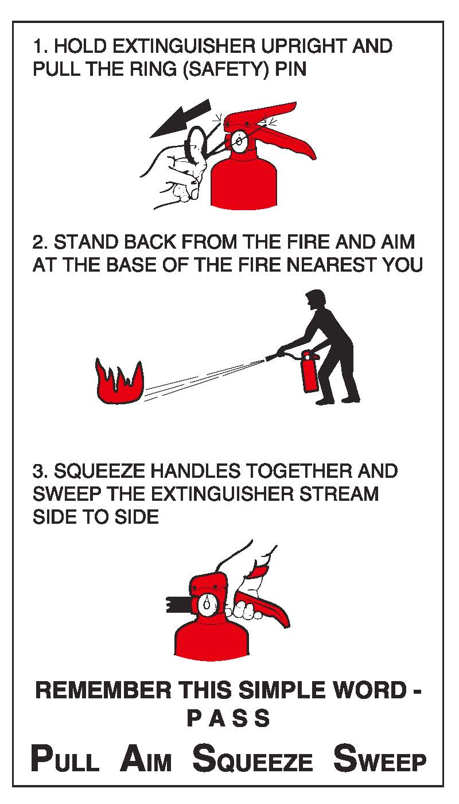

PROTECTION OF ADJACENT FACILITIES

Protection shall be provided for adjacent buildings and facilities that would be exposed to fire originating from areas undergoing construction, alteration or demolition operations.

The following methods and materials shall be used to protect adjacent buildings and facilities from fire:
- spatial separation of ____feet
- water curtains
- gypsum sheathing with 1 hr fire rating
- fire retardant tarpaulins

Where part of the building continues to be occupied, the occupied part shall be separated from the part being demolished or constructed by a fire separation having a fire-resistance rating of not less than 1 hr.

FIRE PROTECTION SYSTEMS

The fire protection system(s) in the building shall remain operational throughout the construction, alteration or demolition operation.

or

Describe which parts or zones of the fire alarm or sprinkler system is to be temporarily shut down.

The following alternative measures shall be taken to ensure protection is maintained:
- fire watch shall be established
- emergency hose lines shall be in place
- portable fire extinguishers shall be in place
- a temporary standpipe system shall be in place with fire department connections
- A temporary fire department connection shall be connected to the sprinkler system
- Sprinklers removed from service will be replaced with temporary smoke detectors
- Etc…..

During construction, the standpipe system shall be installed progressively, in conformance with the BC Building Code.

During demolition, the standpipe system, together with fire department connections and valves, will be maintained in operable condition on all storey’s below the one being demolished, except for the storey immediately below it.

PREVENTING FALSE ALARMS

Activation of the fire alarm system during construction is typically caused by welding fumes, painting fumes, drywall dust and damage to fire alarm wiring and devices.

Describe how false fire alarms can be prevented at the work site. For example: Smoke detectors in the work area will be bagged to keep dust from entering the device. Bags will be removed at the end of each shift. Fire watch will be in effect while detectors are bagged.

The owner or occupier of a property may incur a fee where the Fire Department response to a false alarm is the third or greater number of false alarms originating from one fire alarm system in any twelve (12) month period.

6. FIRE WATCH PROCEDURES

In the event of a temporary shut-down of the fire alarm system or where activities require the interruption of any fire detection, suppression or alarm system component, the site supervisor will:

- Assign a Fire Watch person(s).

- Notify the fire department and fire alarm monitoring company that the fire protection systems are off-line and again when normal operation resumes.

- Notify all occupants in the building of which fire protection systems are out of order and that a Fire Watch has been instituted until the system is back in service.

- Post signage throughout the common areas of the building indicating which fire protection system are out of order and that a Fire Watch has been instituted.

DUTIES OF FIRE WATCH PERSONNEL

- Keep a diligent watch for smoke or fire in affected areas.

- Patrol the affected area at least once per hour on a 24 hour basis while the building is occupied.

- Keep a logbook and record the time each patrol was completed and initial each entry.

- Have fire-extinguishing equipment readily availiable and be trained to use it.

- Call 911 via a cell phone, in the event of a fire.

- Sound a portable air horn or similar device to alert occupants, in the event of a fire.

7. HOT WORKS

This part shall apply to hot works involving open flames or producing heat or sparks, including, but not limited to; cutting, welding, brazing, grinding, adhesive bonding, thermal spraying and thawing pipes.

Hot works shall be performed only by trained personnel.

At least one portable fire extinguisher shall be located in the hot work area.

PREVENTION OF FIRES

Hot work equipment shall be examined for leaks or defects prior to each use. Defects shall be repaired prior to use.

Combustible and flammable material within a 50 foot distance from the hot work shall be protected against ignition.

A fire watch shall be provided during the hot work and for a period of not less than 60 minutes after its completion.

A final inspection of the hot work area shall be conducted 4 hours after completion of work.

Openings in walls, floors or ceilings shall be covered to prevent the passage of sparks into adjacent areas.

EQUIPMENT NOT IN USE

All valves shall be closed and gas lines bled when compressed gas is not in use.

Electric hot work equipment shall be de-energized when not in use.

8. FIRE DEPARTMENT ACCESS

Unobstructed access to fire hydrants and fire department connections shall be maintained.

Describe where firefighters may gain access to all levels or areas of the building involved in construction, alteration or demolition in order to perform their duties.

Describe the access route(s) for fire department vehicles, from closest street to the site.

Where a site is fenced as to prevent general entry, describe the provisions made for access by fire department equipment and personnel.

9. SITE DRAWINGS

SITE PLAN

**Include a site plan showing; the building/work site, location of the site office, adjacent streets, fire department apparatus access, location of closest fire hydrants, location of the fire department connection, location of utility shut-offs and the evacuation assembly area.

FLOOR PLAN

**Include a floor plan for each floor the work is to take place. The floor plan shall include (if applicable) the location of; exit routes, fire extinguishers, fire alarm panel, water shut-off, main electrical shut-off, sprinkler shut-offs, and flammable liquid and gases storage.

**Remove these instructions from the final draft of the plan

